CONFIDENTIAL:

535/3/Inst. Sc.

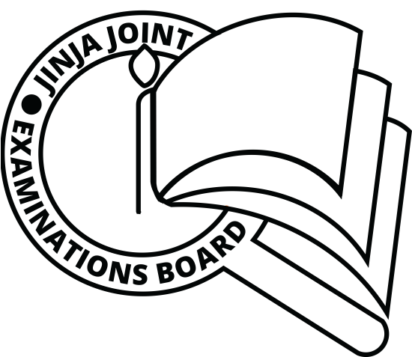PHYSICS

PRACTICAL

INSTRUCTIONS

Paper 3

AUGUST, 2019

JINJA JOINT EXAMINATIONS BOARD

Uganda Certificate of Education

MOCK EXAMINATIONS – AUGUST, 2019

PHYSICS

PRACTICAL

INSTRUCTIONS

Paper 3

INSTRUCTIONS TO THE LABORATORY TECHNICIAN:

Great care should be taken that the information given below does not reach the candidates either directly or indirectly.

The candidates will be instructed not to write out a detailed description of the apparatus.

But the teacher responsible for preparing the apparatus must give details (on the report form attached) about some of the items of apparatus he/she has supplied. The form should be signed by the invigilator, the teacher responsible for preparing the apparatus and the Head teacher.

In addition to the apparatus in the lab, each candidate should be provided with:

Question One

* 1- Retort stand with clamp
* 1- Spring Nullified type
* 6- Masses of 100g including a mass hanger
* 1- Pointer
* 2 pieces of wood
* 1 beaker of capacity 250ml
* 1 metre rule

Question Two

* 1 – Concave mirror of focal length 10.0cm
* 1 – White screen
* 2 – Dry cells in cell holder
* 1 – Switch
* 1 – Screen with wire gauze
* 3-Connecting wires
* 1-metre rule
* 1-mirror holder
* Some plasticine

Question Three

* 1 – Bare Constantine wire of length 105 cm (SWG-28)
* 1 – Voltmeter (0-3) V
* 1 – Ammeter (0-1) A
* 1-Switch
* 1-Dry cell in a cell holder
* 8-Connecting wires
* Cellotape